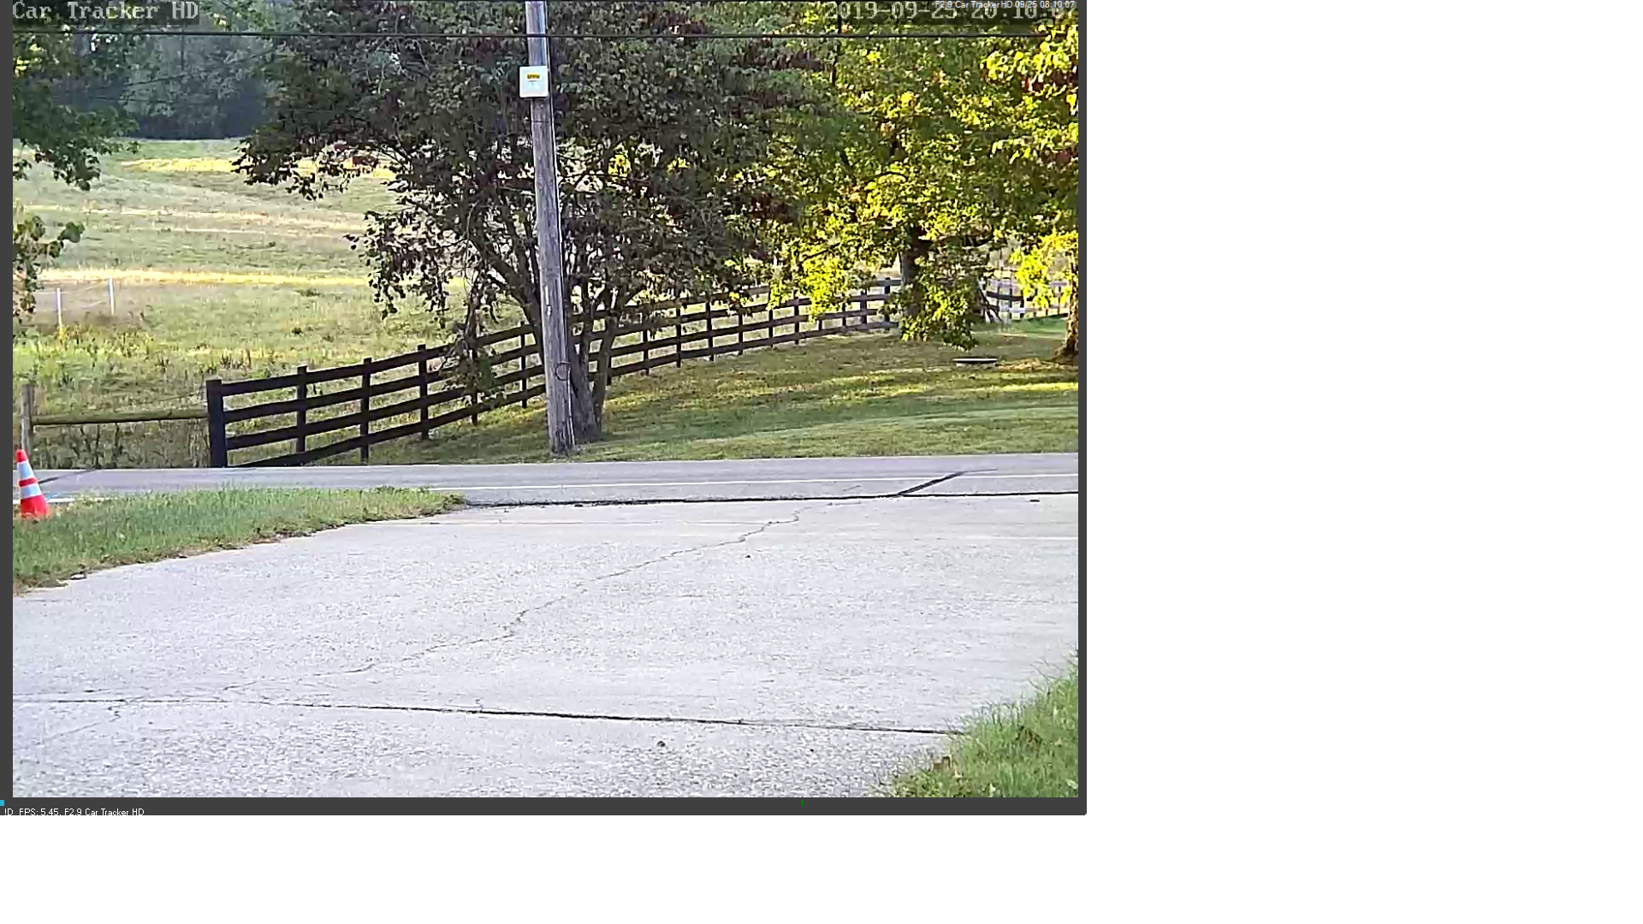

ISPY TRAFFIC CAMERA TOPICS

1 Two Cameras/Resolutions, lens sizes

1. Optimizing an SV3C camera using ISPY.

I and adapting a **SV3C 960p (Wifi) outdoor** camera with ISPY. The distance to the street is about 100ft. I had been using a **12m** camera with a **SRICAM 720p** camera and wanted more resolution such that I could catch license plate info in the driveway (My traffic capture area is at the end of the driveway, so there is a possiblity that I can catch the number of a vechicle coming in the driveway.) I selected a **25m** lens and found the viewing angle is to narrow. I ended up with a **16m** lens.

Viewing Angle - While a smaller veiwing angle gives you better resolution, you must consider these problems. Trigger Time Require, Light available to sensor, Frame rate.

1. Frame rate - You must get enough frames to the ISPY software for it to detect vehicle motion and start recording. If this is the only device on this ISPY unit you should be able to mating a higher frame rate (assuming your network traffic is not too high)
2. Amount of light available - Low Light Levels do not yield good photos. They blurr as the speed of the sensor is greatly reduced at night level. (However a slow or stopped vehicle can yield reasonable photos).

Software issues

There are several software adjustments you need to be aware of.

The first issue is trying to use a camera to sense motion outdoors. Camera software does a poor job of this and the amount of sunlight, movement of clouds, movement of trees causes much problems. ISPY allows you to select rectilinear spaces all over the picture to be used as trigger areas. In general you can select the areas that do not include moving objects. No leaves, clouds, shadown. This is hard. In my particular area I select a narrow area just above the road and beneith the trees. I do not select the road as headlights will trigger recordings earlier than desired.

If you have horizontal shadows you and select narrow vertical areas (rectangles). If you use horozontal detection areas a horizontal shadow would easily trigger it.

3 System Display, Show Car Cam

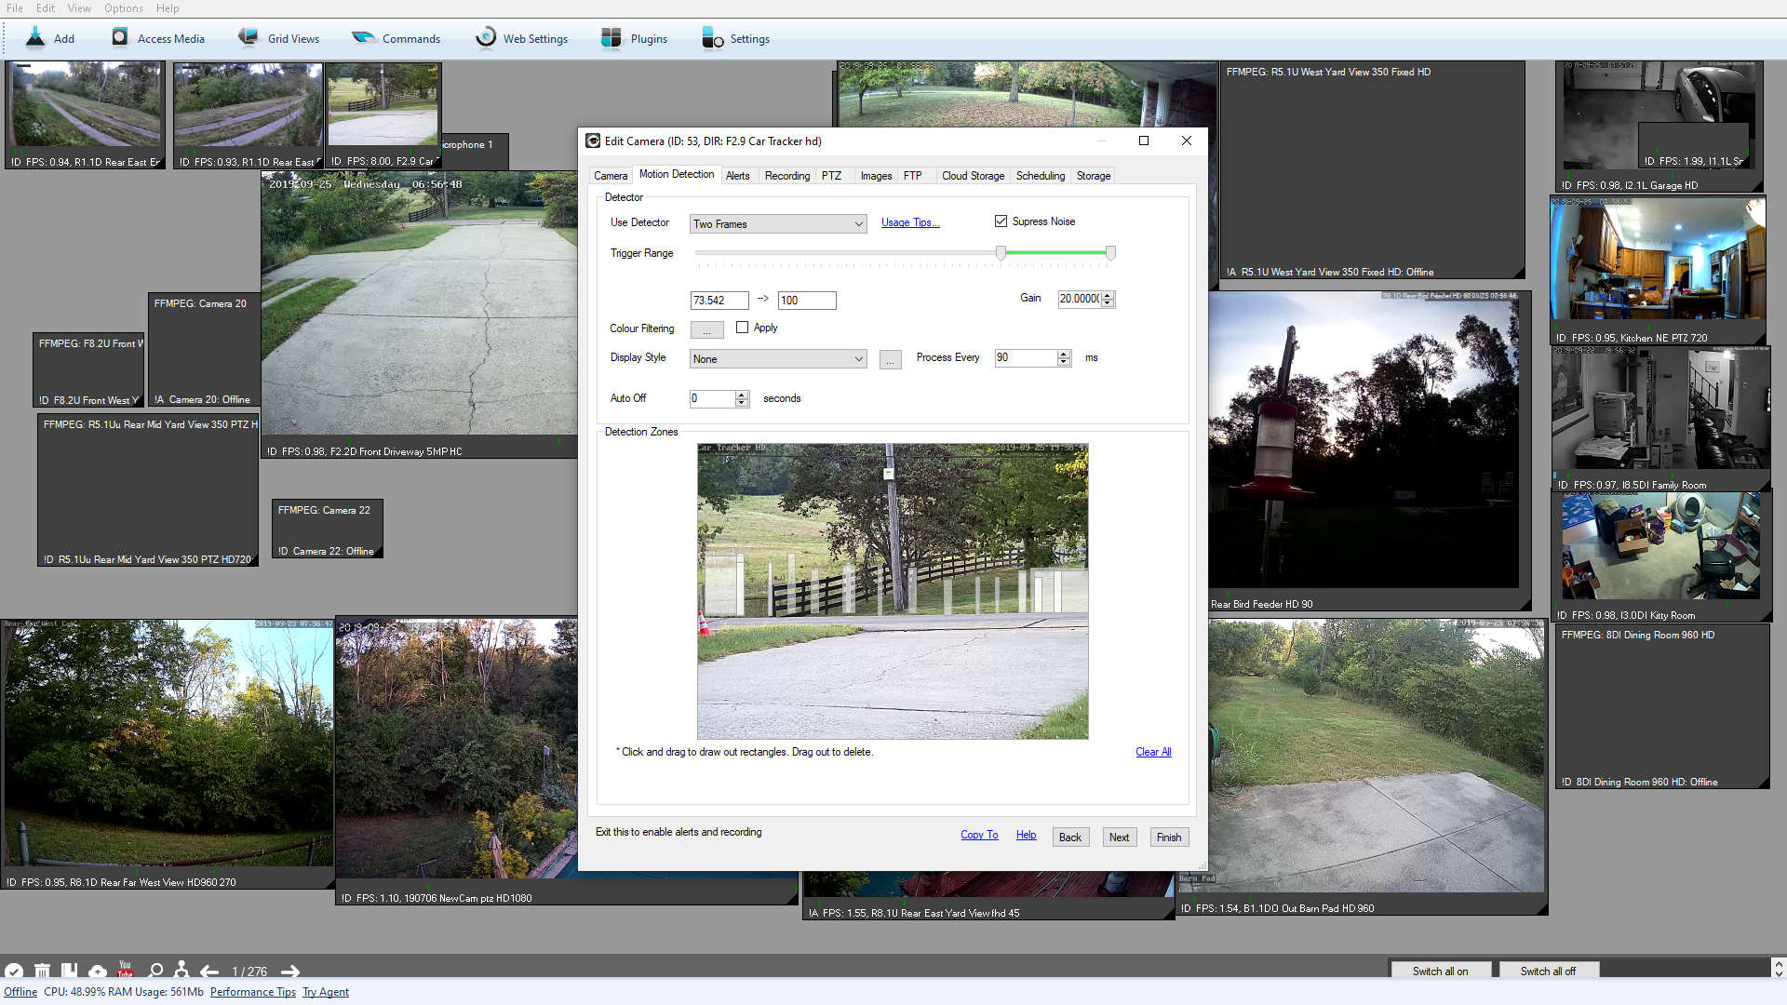

ISPY Configuration Sheet

The correct framerate was integral to the success of this project. If the framerate is too low you miss the camera trigger. Framerates below 6 would simply miss the trigger. iSpy and the camera were unable to handle framerates above 6 well. A framerate setting of 8 regularly caused displayed speeds well above 10 and continuouly variable (normally the actual framerate would regularly match the max frame rate setpoint). I assume framerates above 6 caused and unstable situation in this particular combination of settings.

2^ Frame compares, Trigger Range, Gain, Detection Zones

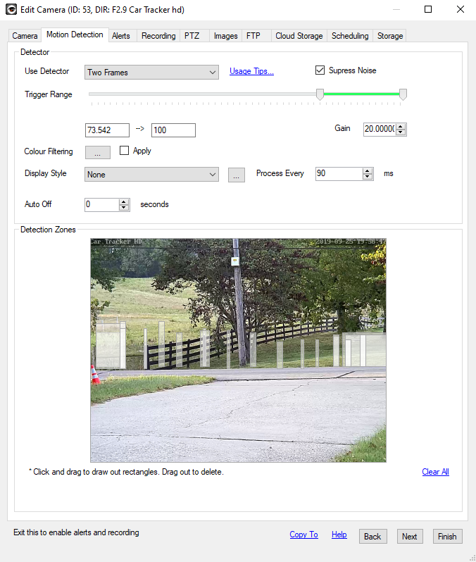

Image 1

Image 1 shows the trigger zones of a working configuration.

This configuration tends to trigger slightly early. It is configured this way so that the video capture captures ALL of the vehicle. The frame capture actually catches a frame AFTER the video starts, so tendancy to catch the front of the vehicle for the video, tends to center the capture of the frame (as it comes later). In this configuration I optimized the capture for the current working characteristic of ISPY.

ISPY Configuration Sheet

Setting parameters on this page was quite trickey and took a lot of trial and error. Setting the “Process Every” interval should be used in conjunction with the Max Framerate. It looks like 200ms if the default “Process Every” value. I tightened this up to 90ms which seems to be optimal with the 6 Max Framerate. I have seen multiple symptoms that I assume were caused by less than optimal values. Low values in this configuration seem to make the whole system disfunctional. Multiple triggers on one frame making a single frame broken up into many pieces.

The Gain and the Motion detect zones are critical for reliable “IN FRAME” videos/pictures.

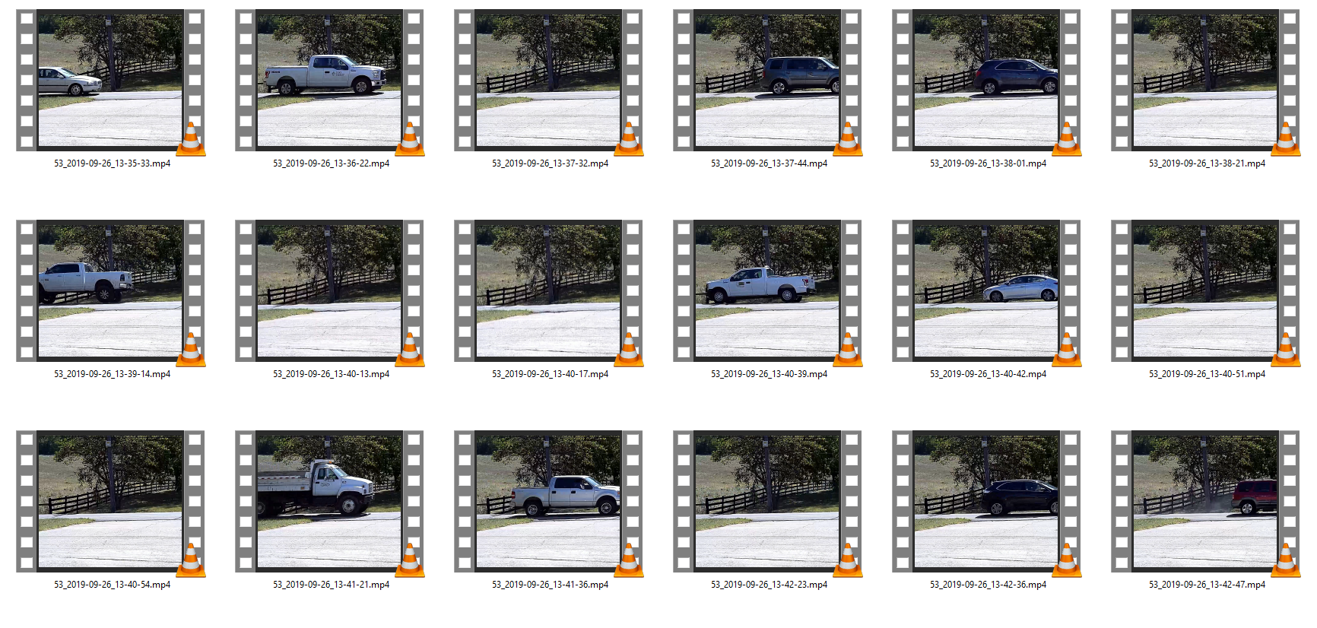

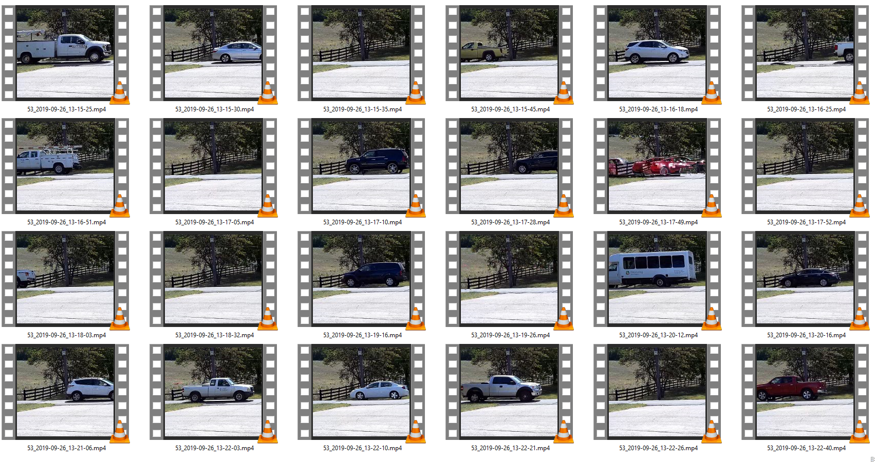

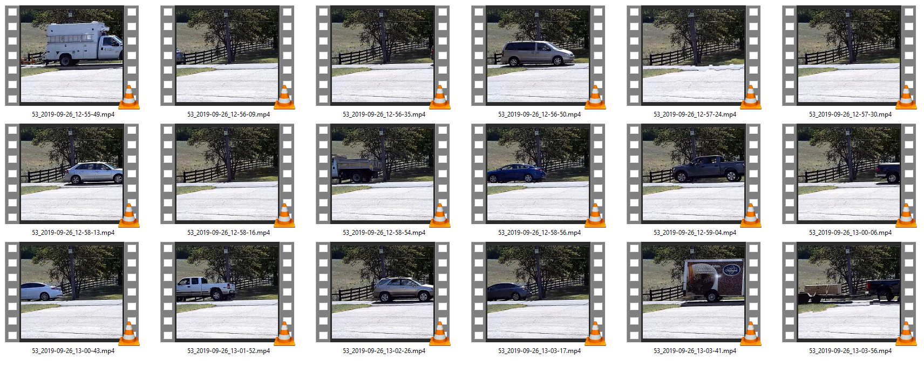

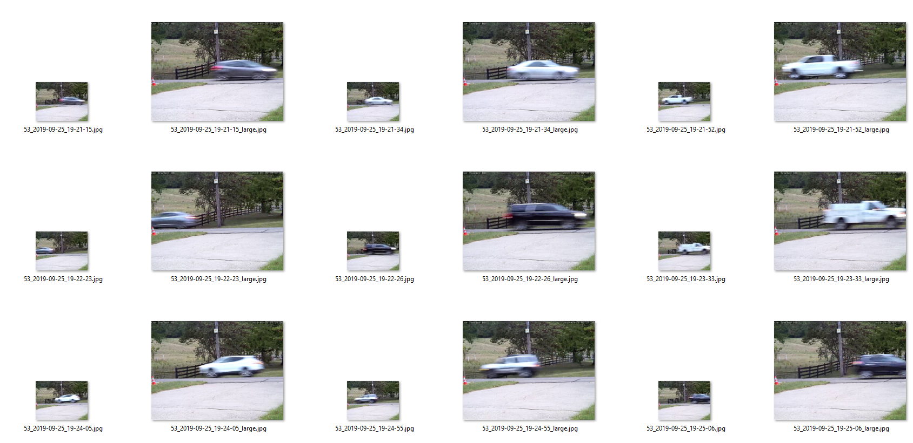

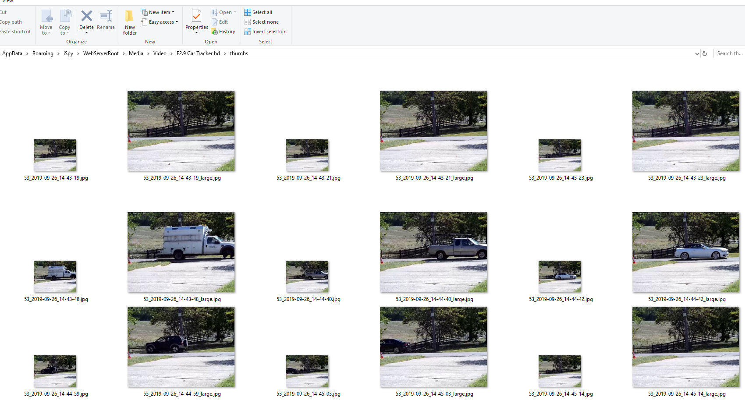

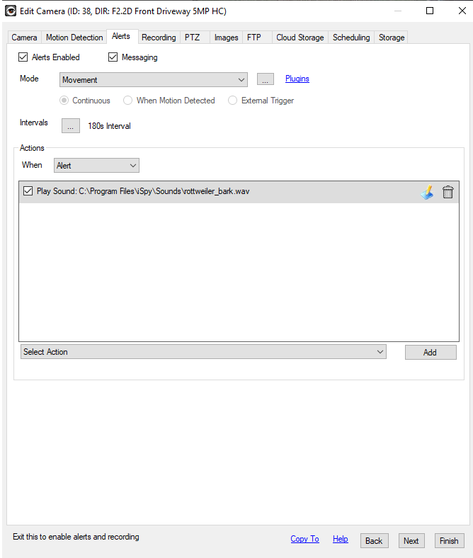

Reset **Alert Interval** (seconds) This is used with the **alert** group. ... Distinct **Alert Interval** (seconds) This is used to prevent multiple **alert** events from a **camera** or microphone. The default value is **180** - which means that **iSpy** won't raise repeated **alerts** for 3 minutes on each event.

It is now obvious that this had nothing to do with the traffic monitor software. In this case it limited an alert (in this case rotweiler barking) to once every 3 minutes. This was a great discovery for me outside of this project as I was wondering my all my audio ALERTS were not working!!!! Multiple alerts were not being heard!!! Now I know why?